Weather Module
To access PanOpt, click on the following link:
http://zulu.geog.ucsb.edu/panopt/index.html
On the right, you will see two sub-headings: Imagery & Analysis and Education. Although you likely accessed this module within the second sub-heading, Imagery & Analysis features the various components and functionality of the PanOpt system:
IDEAS Stations
IDEAS Cameras
SCI Realtime
PanOpt Interface
User Forum
And it is the PanOpt Interface where one can access the various tools of PanOpt. Try clicking one each of the links to see the different PanOpt components.

In this Weather Module, we explore the PanOpt website and try some of the tools available to integrate ground-based photography and imagery from a weather satellite remote sensing device, GOES, with a focus on clouds.

The GOES Satellite
From the main page, click on PanOpt Interface. This is the most essential component of the interface for combined satellite and ground-based analysis that we will be performing in these modules. When you open this webpage, you will see a description of the project as well as links for the three central instruments: GOES, MODIS and webcam. Open the GOES link (http://www.goes.noaa.gov/) and you will see a small number of recently acquired GOES imagery for the five different sectors that it most closely monitors: eastern continental U.S. (CONUS), western CONUS, Puerto Rico, Alaska, and Hawaii. What are the three types of imagery that are on display: Visible, Infrared, and Water Vapor.

Underneath each of the images, you will see two icons, an MPEG (short movie files) as well as a blue movie camera icon. Both of these provide links to recent images so that you can see visualizations for very large areas. You may download these short animations using the MPEG icon, but for simplicity’s sake, click on the blue movie camera icon as it appears below:

Choose an area that covers the region in the US in which you live and watch the Visible imagery short movie that opens up (Note: The Visible imagery will be of most use during the daytime, when the sun is illuminating the region. If you are performing this exercise more than two hours after sunset, you may want to view the Infrared animations instead). In the new window that is shown, about five hours worth of imagery can be viewed, in half-hour steps. You can watch it continuously by pressing Start, regulating the speed with the Set Animation Speed function, or use the back and forward arrows to view it frame-by-frame. You may also zoom in by pressing on the Zoom button and clicking on the image. Look for the area in which you live and watch the imagery movies.

Given that the bright features in the visible band represent clouds, how do the satellite’s observations correspond with the weather you have observed in the past five hours? If you are working with the Infrared imagery, how do these compare with weather conditions – does the same relationship exist between bright areas in the imagery and clouds in the real world?

To find out more about this satellite-based sensor, click on the following link for Frequently Asked Questions: http://goes.gsfc.nasa.gov/text/goesfaq.html. Another neat tool to check out is the Real-time Satellite Data portal (Satellite Observations in Science Education, ESIP-inspired) : http://www.ssec.wisc.edu/sose/real_time.html. This site has Infrared imagery from many sources and you can view imagery for your location by clicking on the map.

One advantage of these viewers is that we can observe real-time imagery for very large areas. Unfortunately, because the area is so large, the web designers have had to greatly reduce the resolution to put the movies together. We are now going to use the same concepts that we applied in your own region for a more detailed look at the Santa Barbara, CA region, where the PanOpt ground-based sensors are based. Working in this region will allow us to also incorporate a great wealth of photos produced by cameras that have been installed.

PanOpt Interface: GOES imagery animations
We will start off by using the Viewer component. From the PanOpt Interface page (http://zulu.geog.ucsb.edu/Data/panopt.html), choose Viewer, and you will see the following page open up:
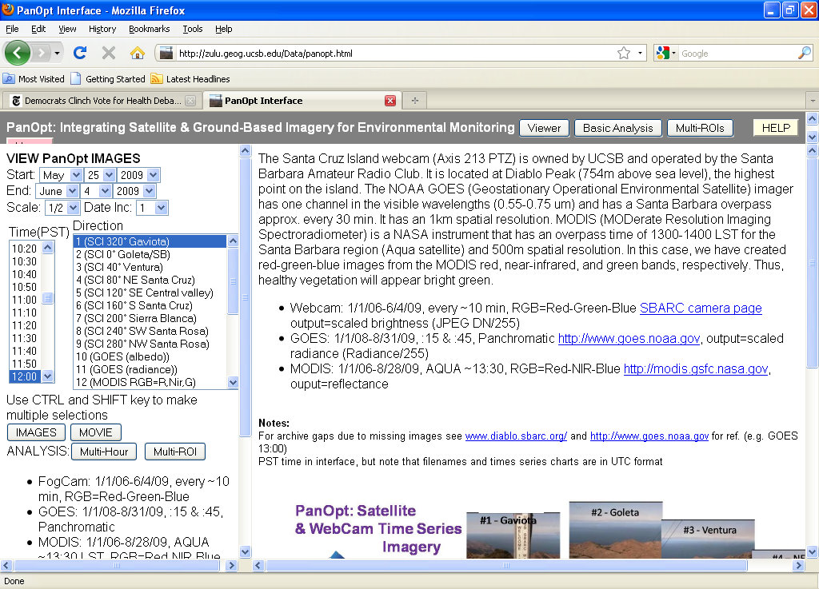

On the left side are menus for selecting imagery from different sensors for different dates and times of day. On the right hand side, there is a general description of the project, and sensors. It is important to note the dates of imagery availability and frequency of acquisition. Webcam is taken every 10 minutes, from January 1, 2006-June 4, 2009. GOES satellite imagery is taken every half hour, from January 1, 2008 to August 31, 2009. MODIS satellite imagery is taken every day, from January 1, 2006 to August 31, 2009. These ranges may increase with periodic updates to the site, however.

Let’s start with one week for which we have both GOES imagery and Webcam imagery: April 5-11, 2009. We are going to view all available GOES imagery for this period. In the upper left, under the words, VIEW PanOPT IMAGES, select April 5, 2009 as the start date and April 11, 2009 as the end date. You can leave the Scale as ½ if you have a small or medium-sized screen, or change to 1 for large screens. Leave Date Inc. (date increment – the number of days it skips ahead at a time) as 1. Below, choose the imagery times. Times are shown as Pacific Standard Time (PST), which is UTC-8 hours and does not include daylight savingsImagery is available daily from 5AM until 9PM (2100h in military time) at night. Select the time range of 700-1900h. To select these multiple times, select 7:00 with your mouse, then hold the [Shift] key down and then click on the ending time, 19:00. Use the scroll bar to the right of the menu items to navigate to different times. Under Direction choose #11 GOES Radiance. Radiance is the term used for general brightness. The menus should appear as follows:
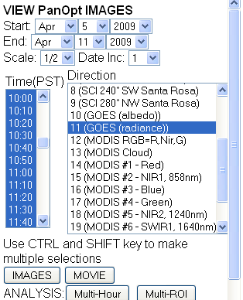

Now, select the MOVIE button below to start playing the animation. Similar to the previous animation, you can control the speed that the animation plays at using the Adjust Speed arrows, or play it frame-by-frame by pushing the Stop button and then using the arrows to go from one image to the next. You will notice that some images are much brighter than others in this movie. This is due to the rising and setting of the sun.

How would one describe the general cloud conditions on each day during this time period? Using the animations, we can see that it was clear the first two days. There were passing clouds the third and fourth day. On the fifth day, we see high, thin, wispy cirrus clouds (most of the area enclosed in purple below) and some smaller thicker clouds over land. It then becomes cloudy again on the sixth day and there are only scattered clouds on the final day.
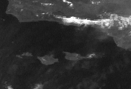

PanOpt interface: GOES and webcam imagery
Now let’s compare how the satellite “sees” the weather during this time period and how it looks from the ground. We have installed and have been operating a webcam on the top of Diablo Peak, on Santa Cruz Island, the largest of the Channel Islands, off the Santa Barbara/Ventura coast of southern California. Open up Google Earth or www.google.com/maps and insert the following latitude/longitude coordinates and you will be taken straight to its location: (34.029448°, -119.784044°). This webcam takes a photograph at nine different angles, making a full rotation once each 10 minutes.

For this exercise, we will be looking at still images, rather than animations. We can stick with the same dates, April 5-11, 2009, but for this, we’ll only look at the noon images (only select 12:00); for Direction, keep the #11 GOES Radiance option, but also choose #2, SCI 0° Goleta/SB. The number refers to the azimuthal looking direction of the camera, which is similar to a compass direction, where due north is 0°, due south is 180°, east is 90° and west is 270° (a graphic illustrating this is found on the PanOpt Interface main page at http://zulu.geog.ucsb.edu/Data/panopt.html). What this means is that the camera was pointed at due north when this photo was taken and considering the camera’s position on Santa Cruz Island, that means that it is looking at the towns of Goleta and Santa Barbara, CA. When you have set up the menus, it should look like this:
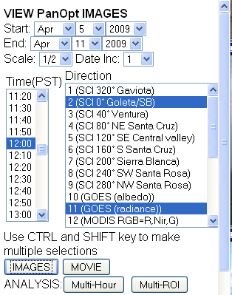
Now, press IMAGES. On the viewing side, you will now see two columns of photos. On the left will be the Webcam photos and on the right will be the GOES images.

We can see different types of cloud formations in this series of images and how they can be viewed differently by the camera and satellite. The general patterns are similar to what was seen in the previous exercise and during this week, a variety of different cloud formations are observed. During the first two days, it is quite clear and neither GOES nor the webcam show any evidence of clouds (4/5/09 and 4/6/09). The third day is quite clouded over as is evident in the GOES image (4/7/09). In the photo, you can see the relatively low cloud base and a generally grayish cast to the photo underneath the clouds. The fourth and fifth days offer an interesting contrast, with clear skies over the water, but some smaller cumulus clouds over the land and the Santa Ynez Mountains on the background (4/8-4/9/09). By the sixth day, we see that there are more scattered orographic (see paragraph below) clouds over the Channel Islands Mountains, which obscure the view somewhat, although the sea is still visible (4/10/09). It is relatively clear again on day 7 (4/11/09), but some scattered cumulus over the Santa Ynez Mountains can be seen clearly in the satellite view and faintly in the webcam.

On day 6 (4/10/09), an interesting cloud formation occurs that demonstrates the complementary nature of the two. Orographic clouds (clouds formed when air parcels are lifted to higher elevations when forced over mountains and become cooled to the point of condensing water vapor to liquid water) can be seen in both images. The webcam’s view is blocked by the immediately surrounding clouds, as seen in the red box below, and as a result, it is difficult to tell how deep the clouds go. The yellow box in the GOES image shows that the clouds are a local phenomenon and that it is actually rather clear across the sea.
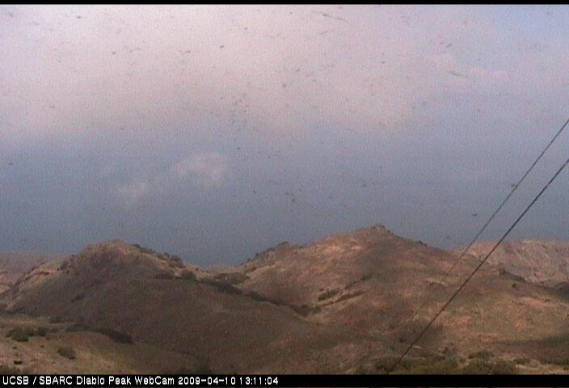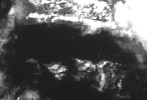
PanOpt interface: Analyzing GOES and webcam imagery
We are now going to analyze, quantitatively, how the camera and satellite “see” clouds.
This can be done in the Multi-ROIs module. You can reach it by clicking on the Multi-ROIs button at the top of the PanOpt Interface or open the following link: http://zulu.geog.ucsb.edu/Data/panopt.html. The page that opens up should look like this:
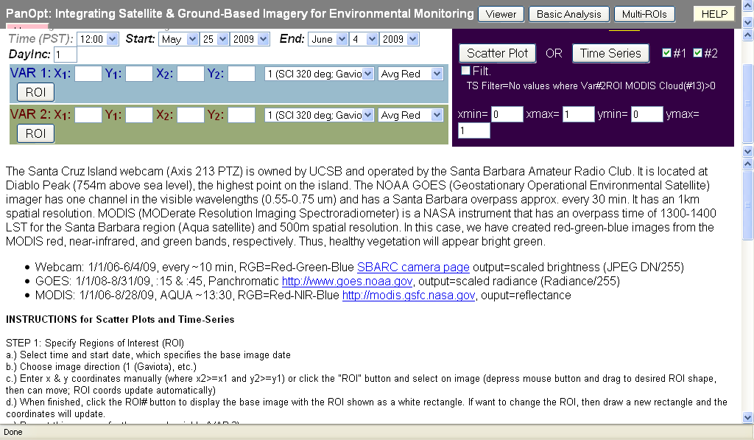
We are going to use this interface to interactively select a region of interest (a rectangle to sample data within) in both GOES and webcam imagery and then perform analysis on these data.

We will continue with the same date range as above. To create our region of interest (ROI) we will select the base time and date of 12:00, April 5, 2009. This is used to specify what image you will draw the ROI on (so if there is a cloud covering the area you are interested in on one date, you can change this to another date). We will make the ROI for Var. 1 (Variable 1) by selecting direction #2 SCI 0; Goleta/SB in the pull down menu, and then Grn/Red (green/red ratio) in the second menu. Clicking on the [ROI] button in the Var. 1 box will open the image. Once open, you can drag the cursor over the image to make a ROI and the pixel locations of its corners are automatically updated in the Var. 1 info box. After you have drawn a ROI you can move or re-size it. See the graphic below for complete illustration of the above instructions. [More detail on ROI creation: Move your mouse cursor to where you want your upper left corner to be, depress the left mouse button and keep it down as you move your mouse cursor to the bottom right corner of your ROI, then release the button].
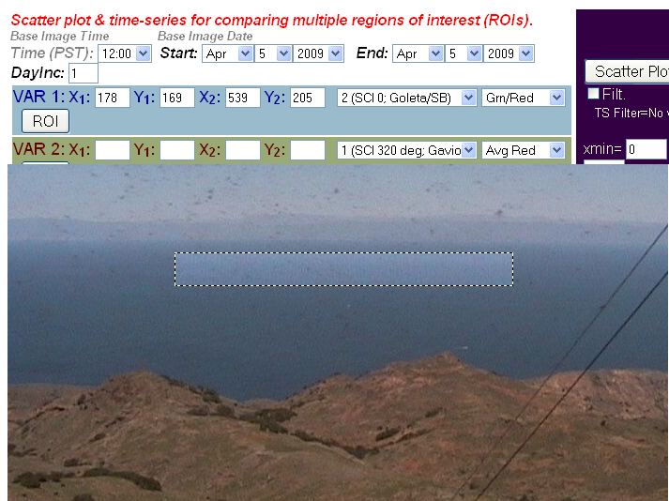

We can do the same for the GOES image but care must be taken to ensure that the ROIs are in the same location and have the same extent. In this case, the camera view is due north and is situated over water. The GOES imagery will be our second variable, so go to VAR 2., select #11 GOES (radiance) and we will be calculating the Avg (average) brightness values for its ROI. Keep the same date and time. After clicking on ROI, the GOES image will appear and we can draw another ROI which automatically updates the VAR 2. parameters, as shown below:
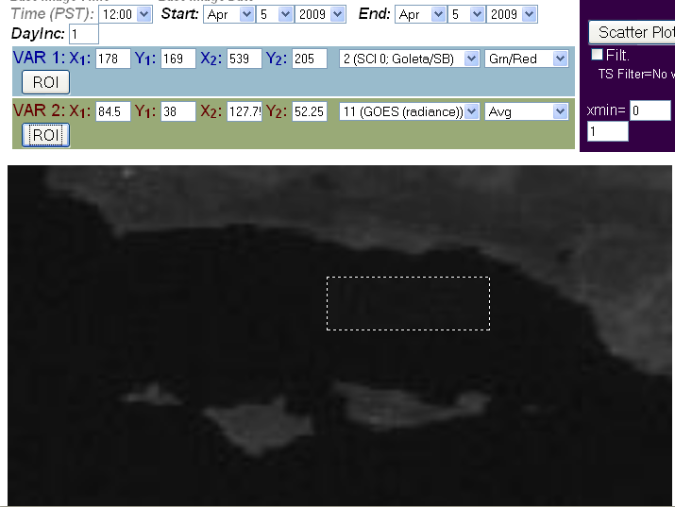
With our ROIs selected, we are now ready to do some analysis. Let’s say that we wanted to determine the midday cloud/fog frequency over the Santa Barbara Channel (the area between the Channel Islands and mainland, as delineated above). The difference between the reflectivity of the open sea and clouds should be relatively apparent from the GOES imagery and discernible by the webcam. To do so, let’s change some of the parameters. We have been working with GOES radiance (general brightness), let’s try switching to #10 GOES albedo for Var. 2. Keep the ROI coordinates that you just set and the metric as average. Also, let’s widen the time frame to allow more data points. Keep April 5, 2009 as the start point, but use June 4, 2009 as the end point. We can also choose how we will see the output under PLOTS, in the purple box to the right. Let’s choose Time Series and change the Y-axis range by changing ymax to 2. We need to do this because the green/red ratio values will exceed the default value of 1. The inputs will look as shown below:
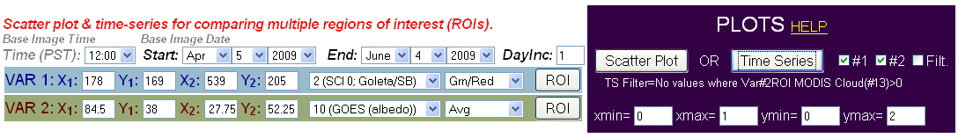
You will now see the time series being shown for two months of webcam and satellite imagery, with the webcam series in black (Var. 1) and GOES satellite imagery in blue (Var. 2). So what do these numbers mean? Well, since clouds are highly reflective and the ocean is not, we know that the low values represent days where there are little or no clouds in the ROI – these points are grouped generally together (<0.2) in the figure below. Higher GOES albedo averages means that the target is brighter on that day, which suggests cloud cover (orange box in figure below). And what is happening in the webcam on these same cloudy days? You can see that on the cloudy days, the webcam green/red ratio dips slightly, as shown in the red circles below.
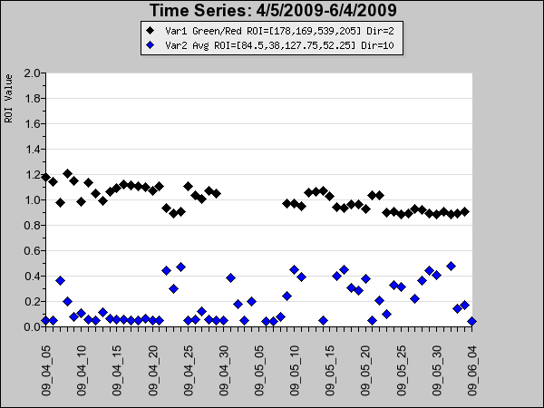
But what was really going in terms of the weather at each of these midday points? One of the strengths of PanOpt is that we can actually see all of the imagery that each of these data points. Make your cursor arrow hover over one of the data points – specifically the May 15, 2009 point that is pointed at with a red arrow below. Now, the GOES and webcam images that correspond to this data point pop up on the right and we can see exactly what the conditions were. In this case, we can see that it was a thick, low fog event, resulting in high reflectivity (albedo) and a dip in the green/red ratio. Why does this ratio change? That is because ocean water is slightly brighter in the green portion of the spectrum, which is why the numbers on clear days are 1.1 – 1.2. In cloudy conditions, the relatively equal reflection of the clouds lowers the ratio to 1.0 or slightly below. It is understandable why the GOES reflectance is so high.
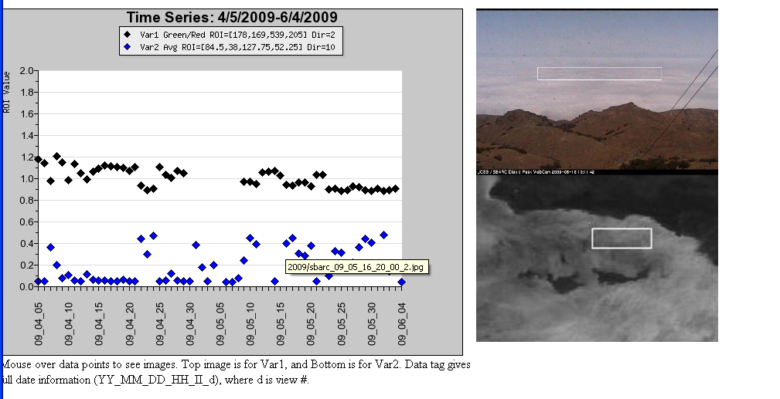
But what about the values that are somewhat lower, such as the point from June 3, 2009, pointed at by the red arrow below? If we hover over that point, we see that this day was characterized by more disparate fog cover and in the GOES ROI, it is only partly covered by fog. Also note that during the last two weeks of the sampling period, the webcam shows relatively consistent ratio values since fog presence anywhere in the field of view will appear essentially the same, whereas in the GOES image, a more spatially-explicit view is given. An advantage of the camera, however, is that one can easily discriminate low fog banks (as shown above) as well as high cloud cover.

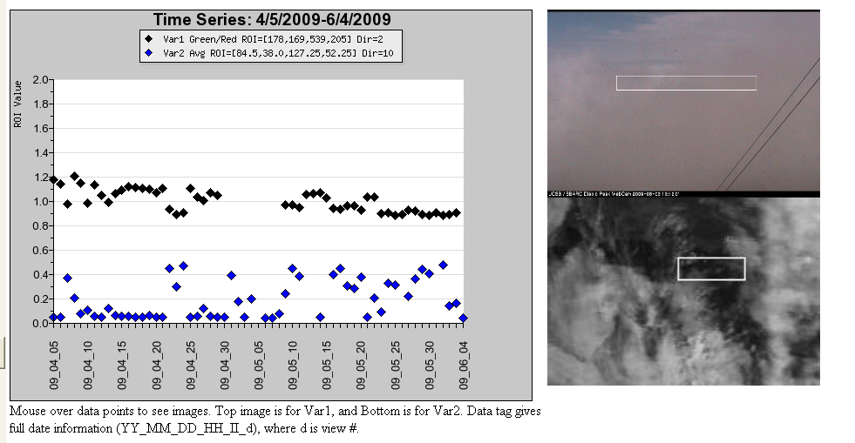
With more inspection of the points, you will see that generally an albedo below 0.1 usually indicates a clear day (at least at the time of acquisition, noon), between 0.1-0.3 indicates partly or scattered fog/clouds and higher than 0.3 is thick fog/clouds.

Another neat way to explore this data is to plot everything not as a time-series but as a scatter plot. This way you can directly see the relationship between the value from the camera and the value from GOES. To do so, all you need to do is click the [Scatter Plot] button under PLOTS instead of the [Time Series] button. Var. 1 will be plotted along the y-axis (vertical) and Var. 2 along the x-axis (horizontal). Set ymin=0.8 and ymax=1.4, so that you can see more detail in the Var. 1 values (leave xmin=0 and xmax=1). The settings and resulting graph will look like the figure below. By moving the cursor over the data points you can see the corresponding GOES and webcam images that serve as the basis for the ROI data points. The bar below the images shows the month of the data point and you can figure out the exact date by reading the data point label (shown in yellow). This has the filename information, which has the parsed date in the form: camera_YY_MM_DD_HH_MM_dir.jpg, where YY=year, MM=month, DD=day, HH=hour, MM=minute, and dir=the direction of the camera. The time is in UTC (also called GMT), which is PST+8hrs. For the data point shown in the figure, the camera filename is sbarc_09_04_08_20_00_2.jpg; this means it is from the webcam and was taken in year 2009, month 4 (April), day 8, UTC hour 20, minute 00, and in direction #2 (SCI 0; Goleta/SB). UTC hour 20 corresponds to 12 PST, noon. Have fun using the tool to explore other dates and sensor combinations! Share your findings on the user forum at http://zulu.geog.ucsb.edu/panopt/.



